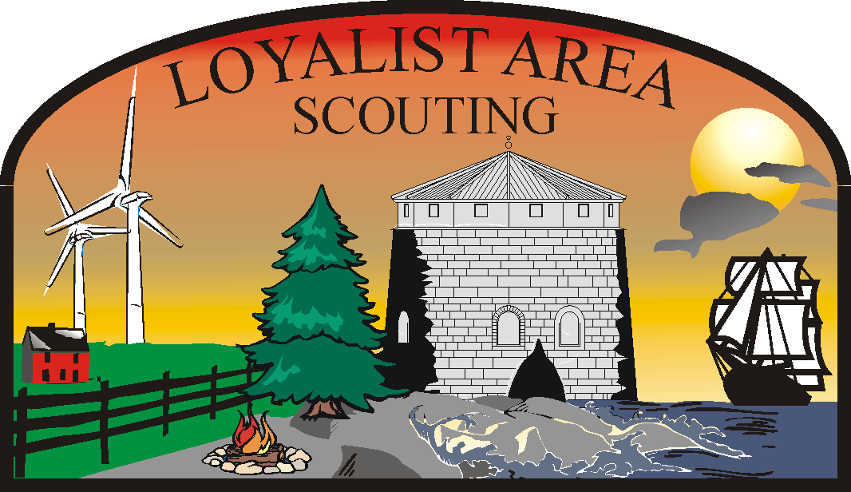

OTTER LAKE (ONTARIO) SCOUT CAMP RULES
Loyalist Area, Voyageur Council

General information About Camp Otter Lake (Ontario)

- CAMPSITES
All campsites have names. Please ensure that you camp on the assigned site.
- BOOKING INFORMATION:
All required facilities must be booked at the time of the initial camp booking. Availability of facilities and assignment of camp sites is at the discretion of the warden.
- POTABLE WATER
The water at Clark hall is potable. Test results are posted in accordance with Public Health Regulations.
- WINTER ACCESS
Snow is removed from the road to Clark Hall. The road may become icy and snow tires are recommended or prepare to hike into the camp.
- TELEPHONE
Cellular telephone is not guaranteed. You may need to move around to find coverage. There is a land line in Clark Hall. Local calls only.
- DOGS AND OTHER PETS.
With the exception of service animals, pets are not permitted on Scouts Canada’s properties.
- DESIGNATED EMERGENCY VEHICLE
Each group must have one vehicle available in camp for emergency use.
- OFF ROAD MOTORIZED VEHICLES:
Off road motorized vehicles are prohibited without prior approval of the Camp Warden.
- TENT TRAILERS AND RECREATIONAL VEHICLES:
No tent trailers or recreational vehicles are allowed
- TREES AND PLANTS: No living tree, shrub or bush may be cut down, or branches removed, without the permission of the Camp Warden. Indiscriminate destruction of plant life is forbidden. Clumps of sod removed must be replaced.
- WILD LIFE: All forms of wild life must be respected and protected. No hunting or slaying of wild life is allowed. This also applies to nuisance animals, racoons, skunks and the like.

- TOBACCO, ALCOHOL, AND ILLICIT DRUGS.
Smoking is not permitted on the property. Alcoholic beverages are forbidden within the camp property at all times. Use and or possession of illicit drugs is forbidden and will be reported to the proper authorities and the appropriate Commissioner.
- FIREARMS AND EXPLOSIVES:
The possession of firearms and explosives of any description (including firecrackers, flares, fireworks or incendiary devices) on Camp property is forbidden. This includes air pressure weapons, sling shots, and archery equipment unless such devices are part of a camp program and prior authorization has been obtained through the Warden and Council IAW BP&P 13016.

CAMPSITES AND TEMPORARY STRUCTURES:
- All campsites have names. Please ensure you camp on the assigned site. Lower Mafeking campsite is adjacent to private property, please ensure you are on Otter Lake Camp property.
- Picnic tables must be returned to their original locations.
- All temporary shelters and structures must be dismantled before you leave the camp.

CLARK HALL:
- The water at Clark Hall is potable.
- Clark Hall provides two kitchens with stoves, fridges and cooking equipment. The stoves and fridges are to be cleaned after use. All dishes, pots and pans must be returned to the storage containers and the containers closed. Do not leave pot scrubbers on or in the sink as they attract insects and rodents.
- The stove tops may not be used for grease laden cooking, as the kitchen lacks the appropriate fire suppression equipment. (For example, cooking ground beef, bacon, etc)
- Do not leave food stuffs behind for the next group, unless permission is obtained from the warden. This building is accessible by mice who will eat your food and leave the processed remnants. Ensure you clean surfaces before you begin using them.
- Thermometers are not to be removed from the fridges and freezer. They are a legal requirement.
- The kitchen floors are to be mopped, and the dining hall floor should be broom clean when you leave.
- The dining tables are to be left clean.
- Do not leave garbage in Clark Hall. All garbage, including recyclable material must be removed from the camp.
- The barbeques should be cleaned after use.
- Do not leave personal items in Clark Hall. They will be removed and destroyed.
- Clark Hall is not approved as sleeping quarters.
- The wood stove is to be used according to the posted instructions. Do not move the thermometer on the stove pipe, this is a safety device allowing monitoring of the stove pipe so that it does not over heat and cause a fire. Tampering with safety devices is an offence. It is forbidden to disable safety devices/alarms.
- Additional sources of heat are not allowed in Clark Hall. The kitchen stoves are to be used for cooking, not to heat the building.

CHAPEL
The chapel is located near Clark Hall.
- The chapel is not to be used as a general camping or activity area. Knives, weapons of all varieties are to be left outside the chapel area.

CAMPFIRES:
- All camp and cooking fires must be constructed in designated fire pits or rings. There are four established campfire pits at Otter Lake (Ontario) Camp, Lower Mafeking, Mafeking, Memorial and Gillespie Field campsites. Fires are to be built and maintained according to good Scouting Practices.
- Adequate firefighting equipment must be available at all times, at least two 5 gallon pails of water for a small campfire.
- Fires, or smoldering firesare never to be left unattended and are to be fully extinguished before you leave the camp.

CEREMONIAL CAMPFIRE:
- The ceremonial Campfire is located at the top of the hill on Gillespie Field. It is designated as a Ceremonial Campfire and must not be used as a “regular” campfire or as a cooking fire.
- The ceremonial campfire is not available for Non-Scouting groups.

PARKING:
- There are 5 parking areas, the main parking lot across from Clark Hall, the turn about, Mafeking, lower Mafeking, and the over flow parking on the way into the camp. Map? Capacity?
- Parking is not allowed on the roadway. Emergency vehicles need a clearance of 25 ft.
- Unauthorized vehicles are not permitted on any of the camping areas.

TOILETS:
- There is one “flush “toilet at Otter Lake (Ontario) Camp, located adjacent to Clark Hall. This facility is wheel chair accessible. Summer availability only.
- There are six pit toilets throughout the camp; 2 at Mafeking, 3 at the top of Gillespie Field and 1 at Memorial campsite. Map?
- Only human waste and toilet paper are to be placed in the toilets.
- Garbage, plastic bottles, feminine hygiene products, glow sticks, articles of clothing etc should be placed in the garbage or recycled as appropriate.
- Toilet tissue is provided at all toilets. Toilet tissue rolls should be returned to the containers provided and the lid replaced.

